The U-Series USB Average Sensor Upgrade Utility is used to upgrade the firmware of Agilent U2000 and U848X Series USB average power sensors. This help file contains quick and easy instructions that will guide you on how to upgrade your USB power sensor firmware by using the Upgrade Utility.
Do not disconnect the USB power sensor during firmware upgrading process.
Step 1 Launch the U2000 Upgrade Utility
Double-click on the U-Series Average Sensor Upgrade Utility.exe to launch the utility.
Step 2 Connect to USB Sensor
- Click Connect on the Upgrade Utility panel as indicated below to begin the process.
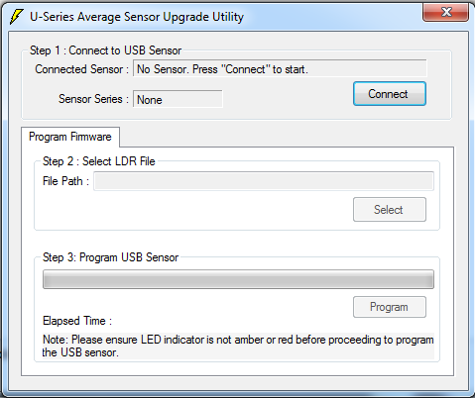

- The USB Power Sensor Selector dialog box will appear as shown below.
- Select the USB power sensor that you would like to update, then click Connect as indicated below.
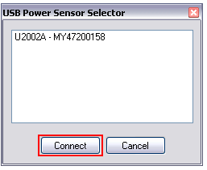
- When the USB power sensor is connected, details of the connected sensor will be displayed.

Step 3 : Select LDR File
- Once the USB power sensor has been connected. Click Select as indicated below to select the firmware file (LDR).
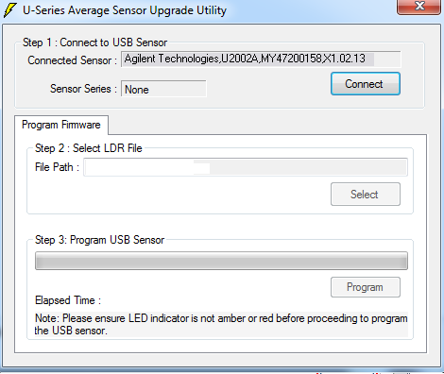

- The Open dialog box will appear. Search for your saved firmware file (LDR) and click Open. When the file is selected, the file path is visible.

Step 4 : Program USB Sensor
- Click Program as indicated below to begin the upgrading operation.
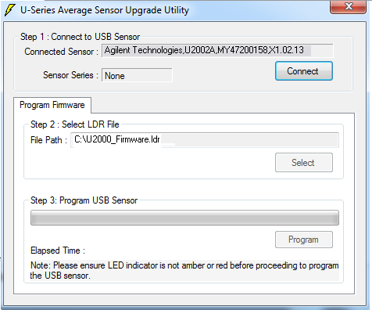

- A warning message box as shown below will appear. Click OK.

- When the upgrading begins, the progress bar will show the upgrade progress as shown below. The file size information and progress time are shown below the progress bar.
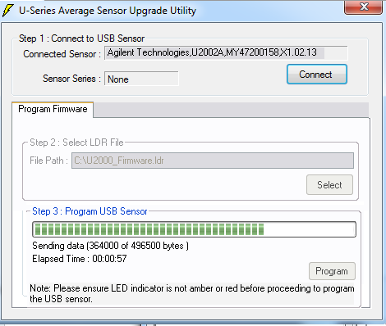

- Once the firmware of the USB power sensor has been successfully upgraded, a message box will appear as shown below to inform you that your USB Sensor has been upgraded.
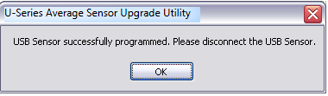

- Unplug your USB power sensor and reconnect the power sensor again.
- Your USB power sensor is now upgraded with the latest firmware and ready to be used.

