Kernel Driver Errors Occurred after Downgrading M9018A Driver from Version 1.2.1.3 to 1.0.1.3

There are two issues to the M9018A Kernel driver that can occur if you downgrade the M9018A driver from version 1.2.1.3 to 1.0.1.3. This documentation will help you verify to make sure your downgrade is successful and show you detail of how to resolve the Kernel driver issues if you have any.
Verify Downgrade:
- After you downgraded from M9018A driver version 1.2.1.3 to 1.0.1.3, power cycle your PC.
- Depending on your Operating System, navigate to the Device Manager.
  - If you’re using Windows 7, at the startup screen of the PC, right click on Computer Properties
  - When the System Properties screen is opened, click on Device Manager.
- At the Device Manager screen, double click on the M9018A Chassis to open the M9018A Chassis Properties screen.
- In the M9018A Chassis Properties screen, if you see no error in the Device status in the General tab, your downgrade is successful.
- If you see error “This device cannot start. (Code 10)” and/or error “Windows cannot load the device driver for this hardware. The driver maybe corrupted or missing. (Code 39)”, these are the two issues to the M9018A Kernel driver that can occur during your downgrade process. Please refer to the instructions below on how to resolve these Kernel driver issues.
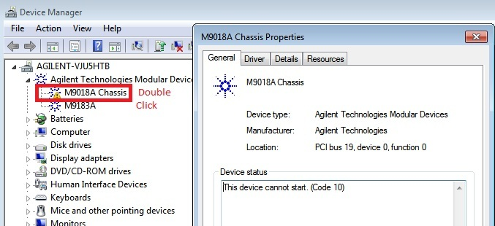

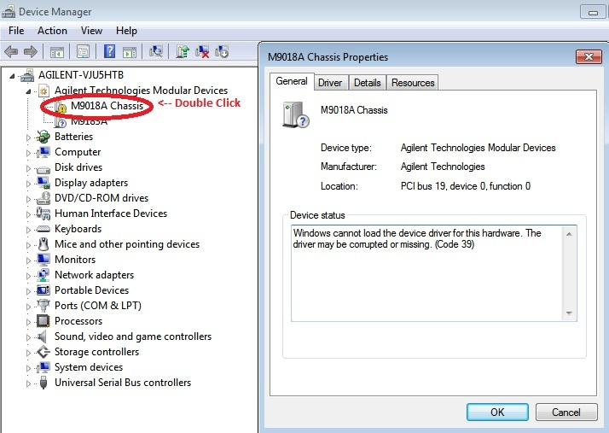

Resolve Kernel Driver Error Code 10:
- Save the below “patchKernelDriverError10.reg” file to your Desktop.
- Double click on the “patchKernelDriverError10.reg” file that you have saved to run the registry patch.
- At the following Registry Editor screens, select Yes and OK.

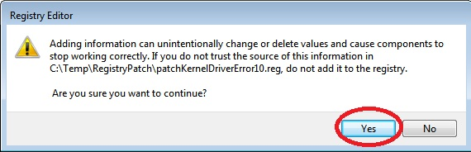
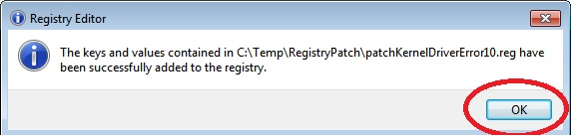
- Power cycle the PC.
- At the start up screen, reopen the Device Manager screen, double click on the M9018A Chassis to open the M9018A Chassis Properties screen and verify that there is no other error in the Device status under the General tab.

Resolve Kernel Driver Error Code 39:
- At the Device Manager screen, right click on the M9018A Chassis select Uninstall.
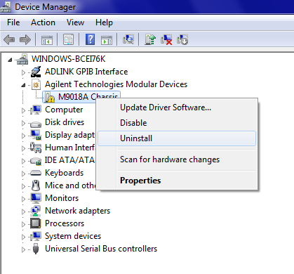
- At the Confirm Device Uninstall screen, check the Delete the driver software for this device and select OK.
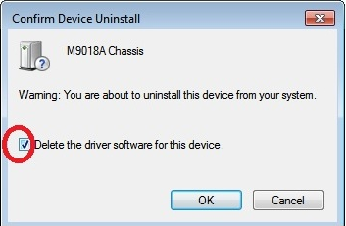
- Open the Control Panel Programs and Features right click on Agilent M9018 select Change
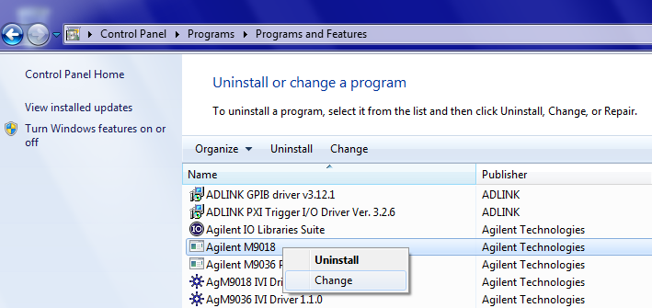
- At the Agilent M9018 – InstallShield Wizard screen, select Repair and press Next.
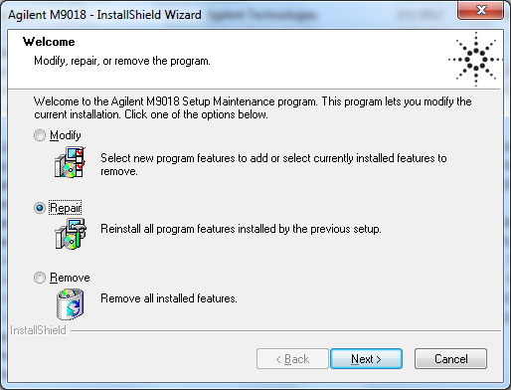
- After the repair is done, power cycle the PC.
- At the start up screen, reopen the Device Manager screen, double click on the M9018A Chassis to open the M9018A Chassis Properties screen and verify that there is no other error in the Device status under the General tab.

