Keysight Truevolt 34460A 6 ½ Digit Multimeter
Keysight Truevolt 34461A 6 ½ Digit Multimeter
Keysight Truevolt 34465A 6 ½ Digit Multimeter
Keysight Truevolt 34470A 7 ½ Digit Multimeter
Firmware Update 3.03 Release Notes
(Previous release: 3.02)

34460A/34461A/34465A/34470A Revision 3.03 Enhancements and Fixes

1. Multiple fixes on Web UI Interactive IO.
- Resolved a defect where Web UI Interactive IO was not able to fetch all available readings.
- Resolved a defect where instrument will display error message “Error caused by remote command” before the entire command is entered and executed via Web UI Interactive IO.
2. Changed the “Slave” terminology to “Secondary” on the error message.

34460A/34461A/34465A/34470A Revision 3.02 Enhancements and Fixes

1. Resolves the memory leak associated with LAN traffic that occurred when the DMM is connected to a LAN network but remains idle for several days.

34460A/34461A/34465A/34470A Revision 3.01 Enhancements and Fixes

1. Improvements to reduce the occurrence of a memory leak associated with LAN traffic that occurs when the DMM is connected to a LAN network but remains idle for several days.
2. Changed the 100 kΩ range calibration to internally select 100 NPLC rather than 10 NPLC to better reject noise associated with selected Fluke 5730 calibration values.
3. Removed Option AVG from the list of available options (Help – About window) as it is not available to all customers.

34465A/34470A Revision 3.00 Enhancements

1. Beginning with Firmware revision 3.00, the digitizing and advanced triggering option (34465A-DIG/34470A-DIG/3446DIGU), is now standard. Instruments upgraded to 3.00 without the DIG option previously installed will show the option as ‘Included’ in the instrument’s Help → About window:

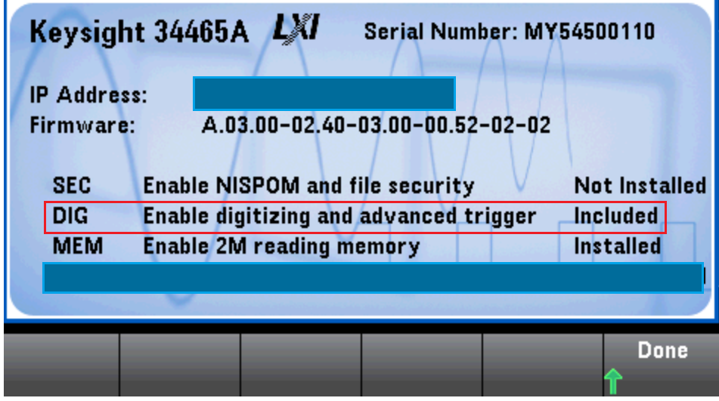

Instruments upgraded to 3.00 with the DIG option previously installed will continue to show DIG as “Installed” in the Help → About window. There is no change in functionality.
Note that all other 34465A/34470A options (SEC, MEM) must be purchased (as before) and installed using the license obtained when the certificate is redeemed.

34460A/34461A/34465A/34470A State File Incompatibility

Instrument state (.sta) files stored using revision 2.x firmware are not compatible with revision 3.00, and therefore, cannot be recalled (loaded) with revision 3.00 installed. State files stored with revision 3.00 can be recalled on instruments with 2.x revisions (e.g. 2.14, 2.17).

34460A/34461A/34465A/34470A Revision 3.00 Enhancements and Fixes

1. Resolved a defect that when performing a calibration step using CAL? and a trigger delay associated with another function was set previously, the calibration could potentially fail.

2. Resolved a defect (34465A/34470A) that when performing an autocalibration (*CAL? or Shift → Utility → Test/Admin → Calibrate → Perform Autocal) with a previously set trigger delay, the time required for the autocalibration to complete increased and the calibration could fail.

3. Resolved a defect that when setting a sample interval (SAMPle:TIMer) > 150s, readings would occur at a rate faster than the specified interval.

4. Resolved a defect that if the DMM was configured as follows:

CONF:AC 1000
VOLT:AC:RANG:AUTO ON
TRIG:DEL 0
READ?
The DMM would return two readings, the first being 0.0000.

5. Adds 2-wire and 4-wire support for 2.25 kΩ and 10 kΩ thermistors in addition to 5 kΩ thermistors.

6. Resolved a defect in the ACV autorange algorithm.

7. Resolved a defect in the default delay for the DCV Ratio input terminal measurement. A ratio measurement is the input terminal measurement divided by the reference (Sense terminal) measurement.

8. Adds HTML5 emulation for additional instrument control options from the WebUI (user interface).

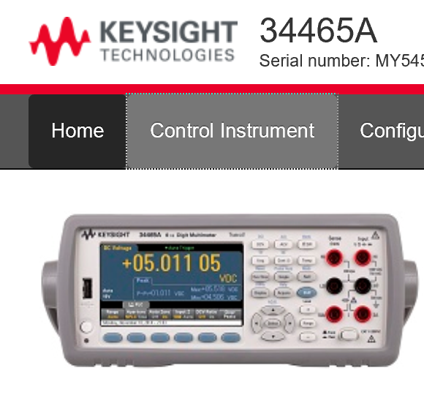
Selecting ‘Control Instrument’ enables selection of the control options:

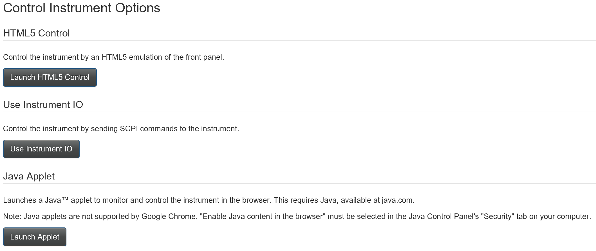
34460A/34461A/34465A/34470A Revision 2.17 Enhancements and Fixes

1. Firmware modifications to support and recognize the new measurement board within the instrument.

2. Resolved a defect that caused the DMM to down-range with a 1000V range specified in the CONFigure:VOLTage:AC command together with SENSe:VOLTage:AC:RANGe:AUTO ON, thus producing two readings.

3. Resolved a defect where the DMM would incorrectly accept negative values for CALCulate:SCALe:DBM:REFerence.

4. Resolved a defect where CONFigure:VOLTage:DC and CONFigure:VOLTage:DC:RATio would not set the impedance (Input Z) to ‘Auto’.

34460A/34461A/34465A/34470A Revision 2.14 Enhancements and Fixes

1. Resolved a defect in the 34460A/34461A that caused an erratic rather than a consistent tone when continuity was detected using the continuity function.

2. Resolved a heater issue with the internal 10 MΩ divider that caused an accuracy shift of several PPM on the 100V and 500V ranges following an ACAL.

3. Optimized the firmware to eliminate potential race conditions internal to the instrument.

34460A/34461A/34465A/34470A Revision 2.11 Enhancements and Fixes

1. Resolved an issue which caused capacitance measurements to intermittently fail with high offset voltages present.
2. Removed/resolved a 3 ppm reading shift that occurred in DCV measurements on the 100V and 1000V ranges when Input Z (impedance) is switched between 10M and Auto.
3. Resolved a Windows Application Error that occurred when LAN service VXI-11 was disabled and power is cycled.
4. Resolved a lock-up condition that occurred during frequency measurements using trigger settings TRIGger:DELay MIN and *TRG.

34460A/34461A/34465A/34470A Revision 2.09 Enhancements and Fixes

1. Resolved a defect in which the detected and internally stored line reference frequency, if 50 Hz, would be changed to 60 Hz following a front panel reset. The stored frequency did not change if *RST or SYSTem:PRESet were sent remotely. (Cycling power senses and restores the 50 Hz setting.)

34460A/34461A Revision 2.08 Additional Functionality

1. Capacitance Measurements

2. Limited Secondary Measurements

3. Probe Hold Remove Last / Clear List

4. Read/Write Media Transfer Protocol (MTP) Capability

5. HiSLIP and IPv6 support

34460A/34461A Revision 2.08 Enhancements and Fixes

1. Communication now restored after disconnecting/reconnecting (or moving) the rear panel USB cable.

2. The ‘down arrow’ key below the ‘Select’ key can now be used to edit settings in the Histogram window.

3. Histogram display now tracks function changes when the display mode is changed.

4. Resolved a trend chart scaling defect in which readings would incorrectly appear outside of the vertical scale limits.

5. Date and time stamp no longer intermittently appears at the top of screen capture images.

6. Bar Meter Limit display resolution increased to separate upper/lower limits in some instances.

7. INITiate followed by a function change will no longer cause errors -230, -420 in response to R?

8. Removed internal errors caused by a fast power cycle using the front panel button.

9. With Option SEC installed, turning off the USB host port from SCPI or the front panel will now disable host port operation.

34465A/34470A Revision 2.08 Enhancements and Fixes

1. WEBUI current state configuration now reports secondary measurements.

2. WEBUI trigger sample interval now includes units.

3. Under certain conditions, changing the Trend Chart Time Window does not erase existing data.

4. Updates to instrument help.
5. Display improvements for Data log and Digitize functions.

6. Recall preferences indicator added to indicate recall is in progress.

7. Message provided that a power-on state file has been loaded.

8. Message window now able to display longer text messages.

9. Ability to now zoom to greater than 100% for lower reading counts.

10. Continuity & Diode histograms now limit auto-binning to 100 bins.

11. Firmware update will now turn the display on (if previously off) during an update.

12. Improved the readability of the limit errors count for the 1k to 1M ranges.

13. Resolved a conflict where the Trend Chart vertical scaling would affect statistics and limit lines in histograms for the frequency/period function.

14. Resolved a defect when the user state file was not located at power on would cause statistics, histograms, and trend charts to not acquire measurements.

15. Resolved a defect in which setting SAMPle:TIMer MIN would return an error.

16. Resolved a defect where the number of samples in the Statistics window would round to values of 10 in the 10k to 100k range.

17. Improved Trend Chart auto scaling rate when measuring low capacitance values.

18. Resolved a defect where low noise levels in capacitance measurements would cause a Trend Chart "Autoscale Once" failure for scalable inputs.

19. Resolved a defect where changing the manual trigger delay, sample count, sample source, voltmeter complete polarity, or upper/lower limits would clear readings.

20. Added the ability to allow a semicolon in a file name.

21. Updated error messages that occur when recalling an instrument state with settings available through a license option in a unit without the appropriate license.

22. Added the ability to allow scaling units entered from the front panel to include punctuation and special characters.
23. Resolved a defect in which SAMPle:TIMer MIN for Ratio measurements would cause sample timer errors.

24. Resolved a defect in which the Auto Trigger Delay values set from the WEBUI were over-ridden by the instrument after the settings were applied.

25. Resolved a defect where the WEBUI did not update to the state recalled from the front panel without receiving a trigger first.

26. Setting auto-trigger from the front panel now sets the pre-trigger count to 0.

27. Resolved a defect where the ‘voltmeter complete’ pulse rate was approximately 10X the reading rate for auto-triggered front panel ACV/ACI measurements.

28. Resolved a defect which now allows a 1M row limit for readings saved from the front panel.

29. Resolved a defect in which ACV measurements with DCV secondary measurements would provide incorrect DCV readings under certain conditions.

30. Improved Trend Chart display of thermocouple measurements.

31. Statistics from front panel initiated measurements are now updated when subsequent SCPI commands are sent to the instrument.

32. Resolved a defect where the WebUI SCPI Command History -- had more commands in memory than were sent to the instrument.

33. Resolved a defect which now allows the sample interval to be set from the WebUI Trigger Settings.

34. Resolved a defect in which Trig Timer settings using the WebUI are not erased after ‘Apply’ is selected.

35. Resolved a defect that would cause a WebUI out of memory crash.

34460A/34461A Revision 1.10 Enhancements and Fixes

1. Adjusted the limits within the AC Offset self-test that were set incorrectly. This could cause the 34460A/34461A to report the self-test had failed when the instrument was functioning within specification.

34460A/34461A Revision 1.09 Enhancements and Fixes
1. Reduces DMM boot time from ~ 50 seconds to < 30 seconds.
2. Adds a query which returns the DMM power on duration since the last power cycle. This is accessed from the front panel by pressing:
Shift → Utility → Test/Admin → Calibrate → Show Uptime
or by sending the command: SYSTem:UPTime?
3. Adds the ability to turn off the key “click” when a front panel key is pressed. This is accessed from the front panel by pressing:
Shift → Utility → System Setup → User Settings → Sounds → Key Click (Off/On)
or by sending the command:
SYSTem:CLICk:STATe (OFF/ON)
4. Now displays the current level associated with diode measurements.
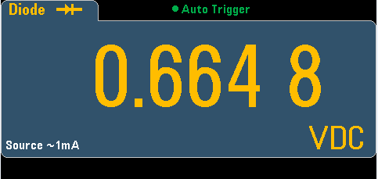
5. Resolved a defect such that a wildcard (*) used with MMEM: or MMEM:DEL now operates in the same manner.
6. Resolved a defect such that sending a Device Clear while *TST? or TEST:ALL? is in progress no longer locks up the instrument.
7. Resolved a defect such that sending a Device Clear while a self-test in in progress no longer causes
-310, “System error” and/or self-test failed errors.
8. Modified the message regarding changes to the DMM’s LAN Services to avoid confusion. For new service settings to take effect, press:
Done → Apply Changes
and then cycle power.
9. Resolved a defect such that DISPlay:VIEW TCHart will now display data independent of the CALCulate:AVERage:STATe setting.
10. Resolved a defect such that DATA:REMove? No longer intermittently generates -230, “Data corrupt or stale” errors when sufficient readings are available.
11. Resolved a defect such that selecting Default Preferences from the front panel:
Shift → Utility → Store/Recall → Set to Defaults → Default Pref
now sets the default ‘Easy File Access’ setting (OFF).

