Agilent 8990B Peak Power Analyzer (PPA) FW/SW upgrade procedure
Updated: 25 Apr 2012
Pre-requisites:
The 8990B PPA is running on Window 7, else please contact your Agilent representative to have the unit upgraded to Window 7.
- Copy the installer file (PPAxxxxx.exe) to the local drive or desktop of the 8990B PPA.
- Double click on the exe file. The installer will start to prepare the upgrade, shown below.
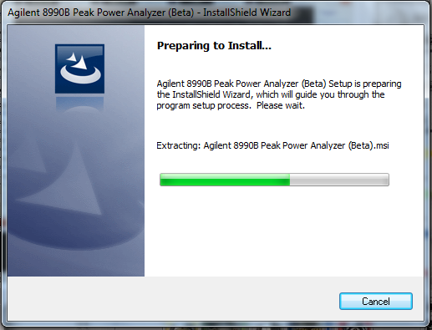
- Please read the Agilent software licensing agreement pop up dialog window, click “I accept…” and Next.
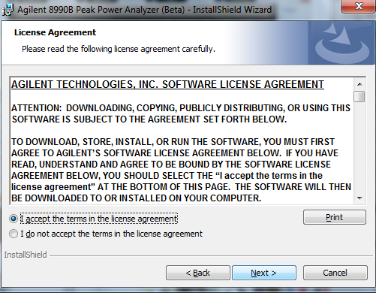
- Installation will start; the progress status window is shown as follow. The Firmware (FW) upgrade will take as long as 15 minutes to complete. The dialog window will close automatically after the upgrade is complete.

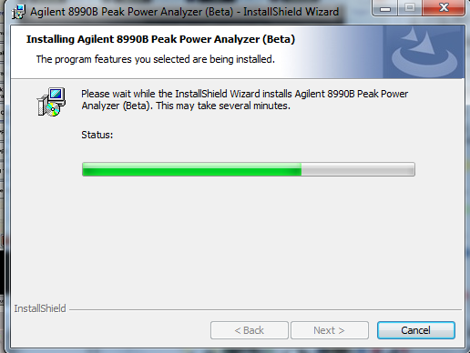

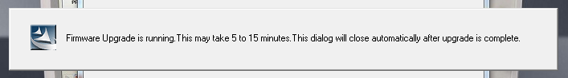

- Once the upgrade process is completed, click OK on the “Complete” dialog window.
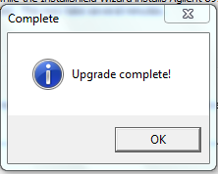
- Finally, a full shot down of the PPA is required as follow, click “Yes” for the shutdown. After the shutdown, please wait at least 15 seconds before restarting the PPA.
