U1115A Firmware Update Procedure
- On the U1115A, change the “Role” to “Slave” by following the steps below.
  - Connect Bluetooth Edit 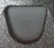 OK
- Right click on the PC Bluetooth icon.
  - Click on “Add a Device”.
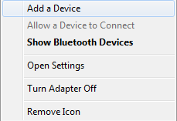
  - Select the U1115A to be connected and click on “Next” to proceed.
Note: different U1115A units will have different MAC address.

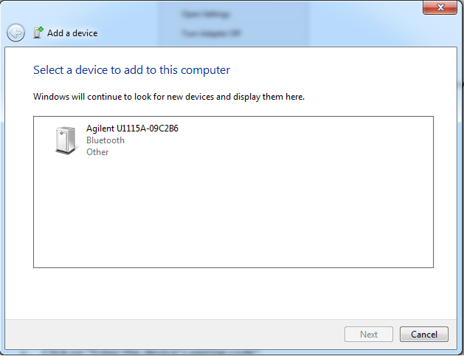

  - Click on “Enter the device’s pairing code”.

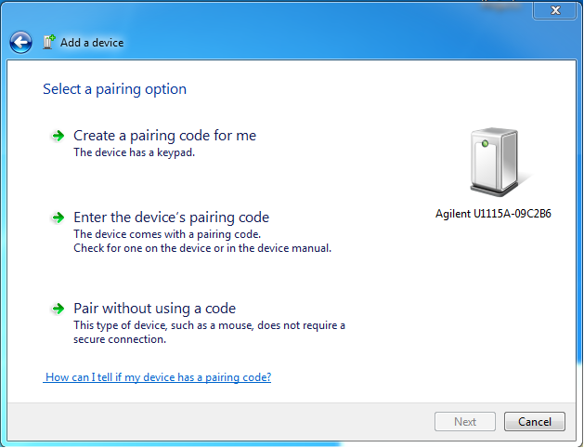
  - Key in pairing code “1234” and click “Next” to proceed.

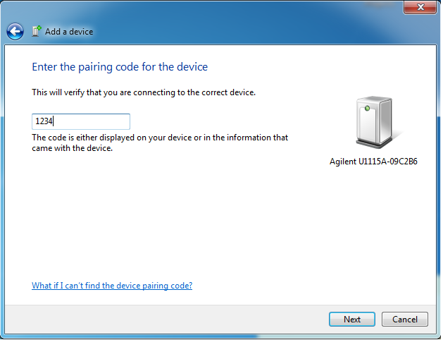

  - The message below will appear when the pairing is successful.
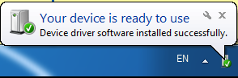
- Right click on the PC Bluetooth icon.
  - Click on “Show Bluetooth Devices”.

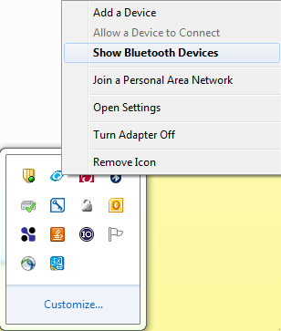

  - Right click on the U1115A unit connected Properties

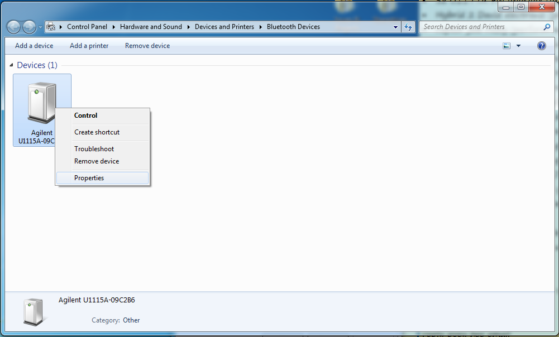

  - Click on the “Hardware” tab to see the COM port which the U1115A unit is connected to.
Note: Different PC might have different COM port value.
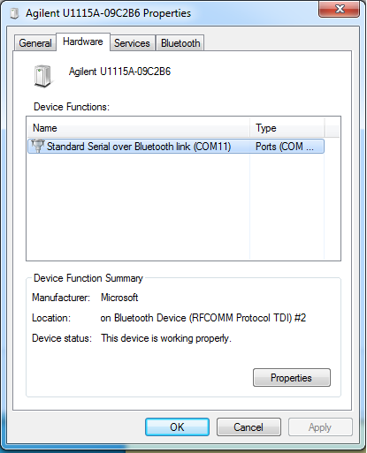
- Double click on “U1115AFirmwareUpdatePackage”.
  - Select the COM port as per Step 3(c).
Note: if the COM port value does not appear in the drop down list, please click on “Update Port” to refresh the COM port list.

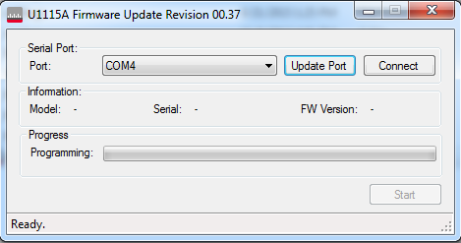

  - Click “Connect” and wait until the “Start” button is enabled.

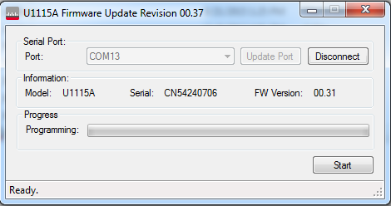

  - Click on “Start” and wait until the programming is complete.

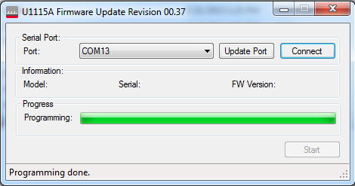

- You may check the firmware version by following the steps below.
  - Settings More System Sys Info

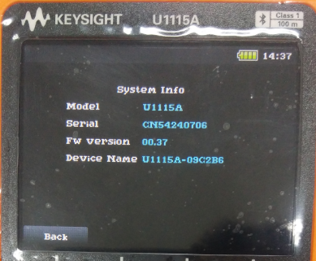
After programming

- Set the unit to factory default setting by following the step below.
  - Settings More System Reset Yes
Unit will reboot automatically.

